**Phase 3**

**Goal: Build data structure.**

1. **Standard & Custom Objects**
   * **Standard: Contact (customers), Products, Orders.**
   * **Custom: Alterations & Custom Orders, Appointments, Style Preferences, Supplier.**
2. **Fields**
   * **Alteration & Custom Orders: Alterations & Custom Order Name,** **Delivery Date, Notes, Customer Name, Order Number**
   * **Appointments: Appointment Name, Appointment Date, Purpose, Status**
   * **Style Preferences: Style Preferences Name, Category, Colour, Size, Style Notes**
   * **Supplier: Supplier Name, Contact Number, Product**

**Screenshots**

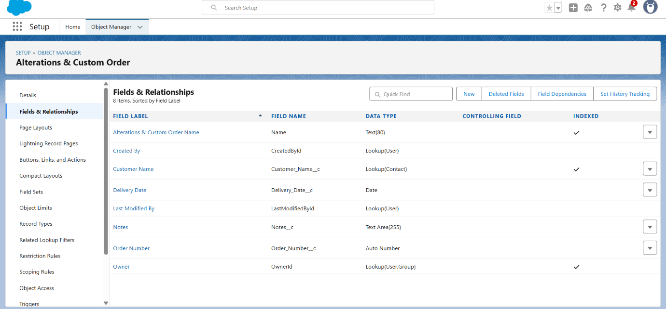

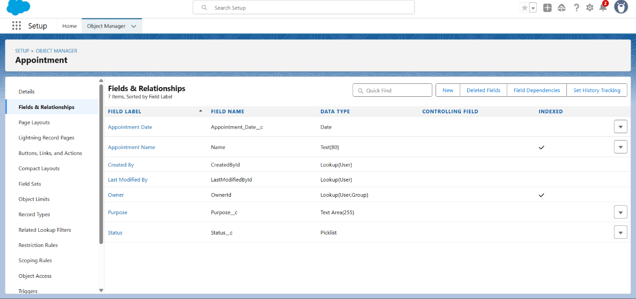

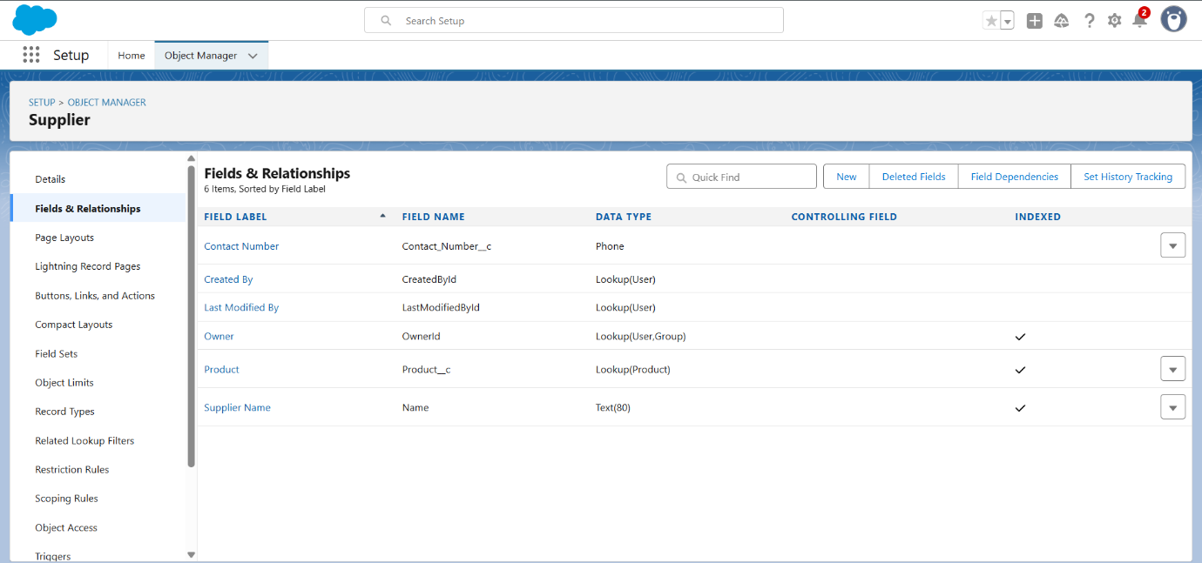

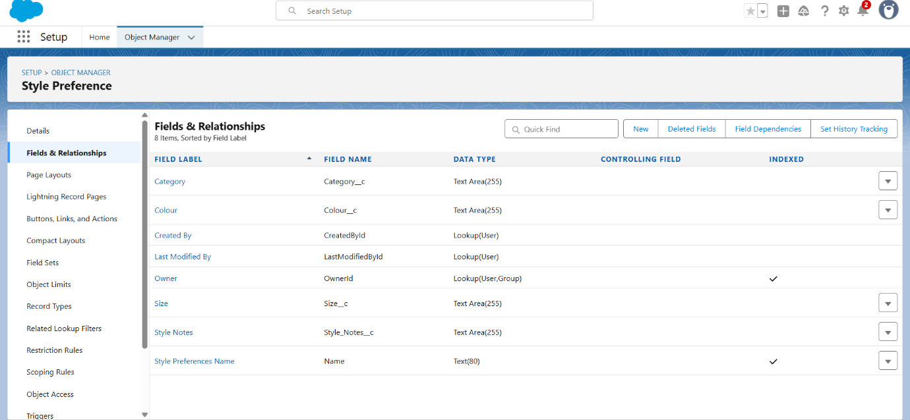

1. **Schema Builder**

